34.41: a) 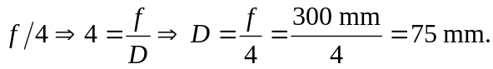
b) 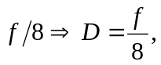so the diameter is 0.5 times smaller, and the area is 0.25 times smaller. Therefore only a quarter of the light entered the aperture, and the film must be exposed four times as long for the correct exposure.

